**Exercise 10: Implementing the MVC Pattern**

* **Create a New Java Project:** Create a new Java project in your preferred Integrated Development Environment (IDE), such as Eclipse or IntelliJ IDEA, and name it *MVCPatternExample*.
* **Define Model Class:** Create a class named *Student* with attributes like *name, id,* and *grade*. This class should have a constructor for initializing these attributes, and getter and setter methods for accessing and modifying them**.**
* **Define View Class:** Create a class named *StudentView* with a method *displayStudentDetails().* This method should take the student's name, ID, and grade as parameters and display them to the console or user interface.
* **Define Controller Class:** Create a class named *StudentController* that manages the communication between the *Student* model and the *StudentView* view. This class should have methods to update the model's data and a method to update the view based on the model's data.
* **Test the MVC Implementation:** Create a main class to demonstrate the functionality of the MVC pattern. This class should prompt the user to enter initial student details, create instances of the Student, *StudentView*, and *StudentController* classes, and then display the initial details using the view. It should also allow the user to update the student's details and display the updated information.

Each of these steps ensures that the MVC pattern is correctly implemented by separating concerns:

* **Model:** Manages the data and business logic.
* **View:** Handles the presentation of the data.
* **Controller:** Acts as an intermediary between the model and the view, handling input and updating the model and view accordingly.

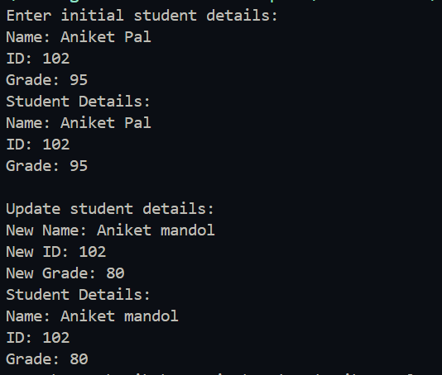

Here is the output of the program

Here is the code- link